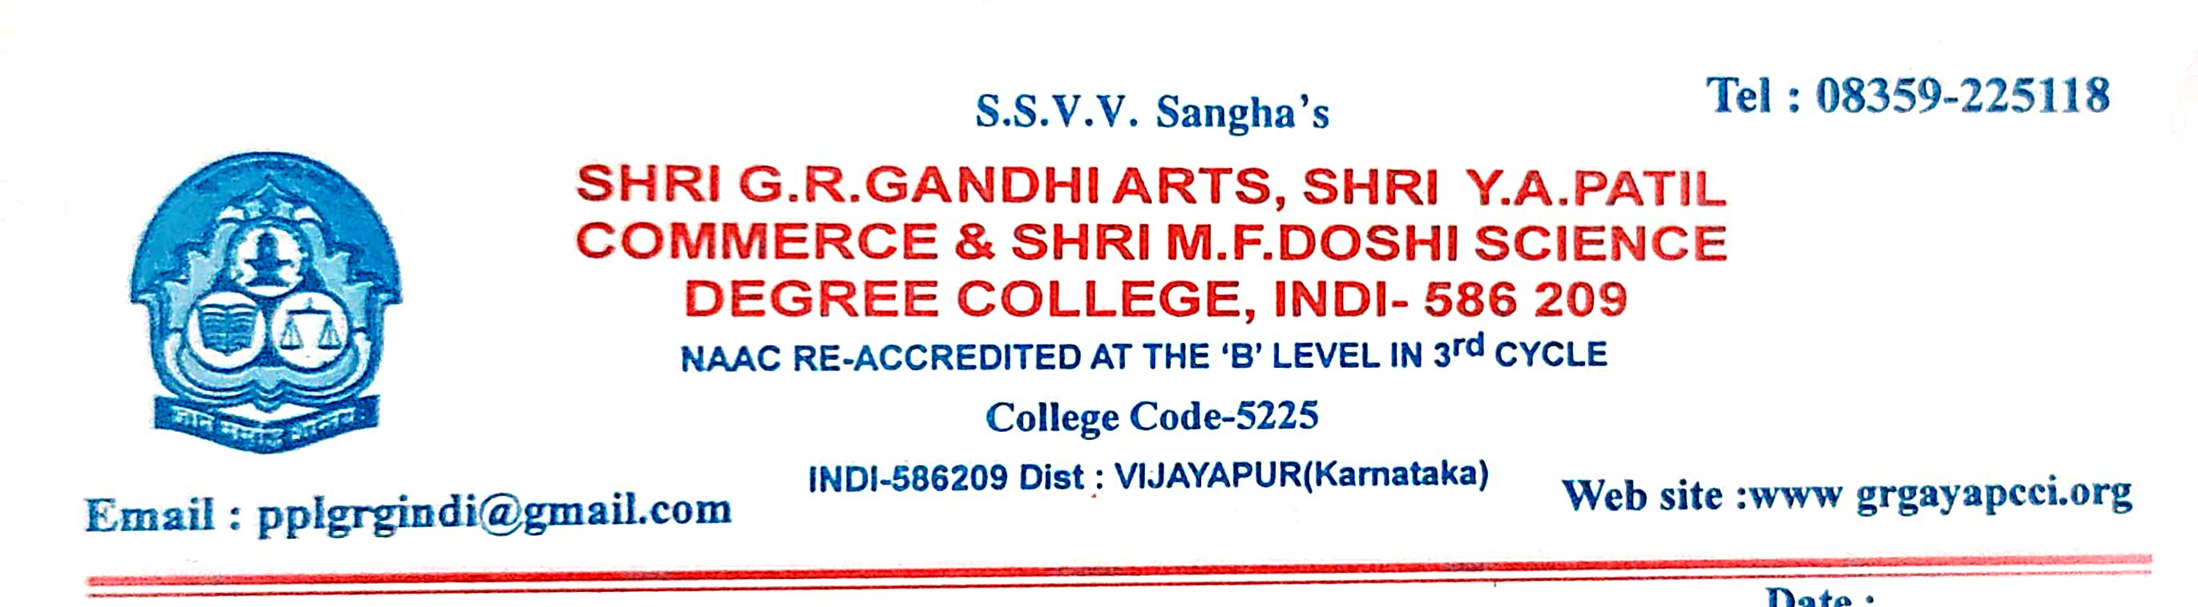
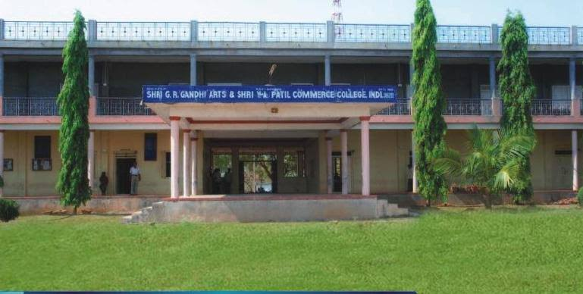
CRITERION VII - INSTITUTIONAL VALUES AND BEST PRACTICES 7.3 - Institutional Distinctiveness
7.3.1 - Portray the performance of the Institution in one area distinctive to its priority and thrust
Institutional Distinctiveness
2021-22

7.3 - Institutional Distinctiveness
The institution is to impart excellent education in arts, commerce, computer applications and social work to the utmost satisfaction of the students and stakeholders. To provide dedicated, committed services to economically challenged rural students through effective teaching. To develop academic excellence and character building. To empower students to learn through sharing, enhance team work, leadership qualities and provide extension services to themselves and society.
Our institution provides high-quality facilities to fulfill the student's needs in the respective area of career opportunities and placement assistance. The Placement cell organizes and extends services towards collaborative placement through the ICICI Bank activities i.e. The cell conducts training activities for the B.Sc B.Sc(CS), BA, and B.Com students mainly focusing on Career planning, Personality Development Industry Institute Interaction, Campus placements. Continuous interaction of the cell with the Alumina also helps in achieving the goals & motivating students to contribute in this direction. As on more than 209 students placed in eminent IT industry like Fidrox India PVt Ltd, G4Security, Muthoot FIncorp, J K Tyres, etc. Our goal is to set up a knowledge hub where Career Opportunities follow students not the vice versa. The college has created an interactive and stimulating environment by organizing various student-centric activities such as programming Competitions, Essay Writing competitions, competitions, Debate competitions, Speech competitions, workshops, and seminars. Students can build their knowledge through study facilities libraries, reading rooms, e-resources etc. for their personality development.
INAUGURATION OF JOB FAIR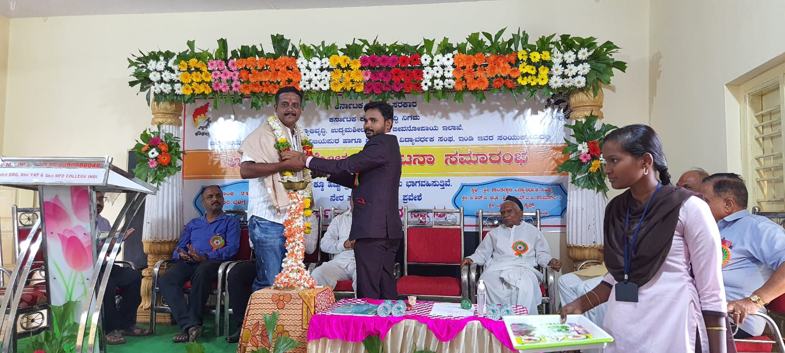
JOB ORIENTATION PROGRAMME ORGANIZED BY ICICI BANK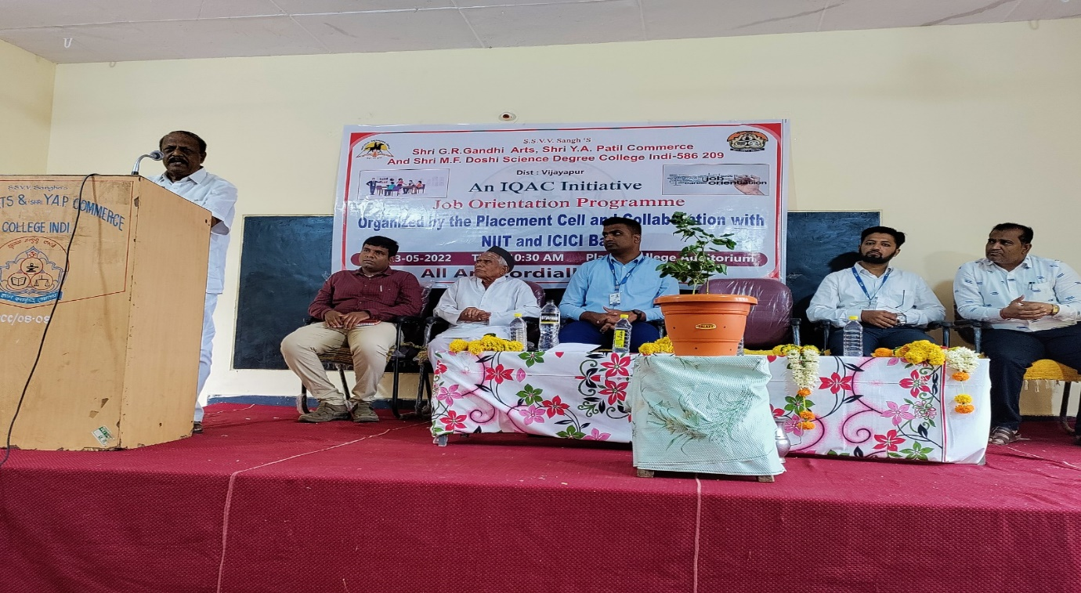
PLACEMENT COMPANY REGISTRATION AND INTERVIEW
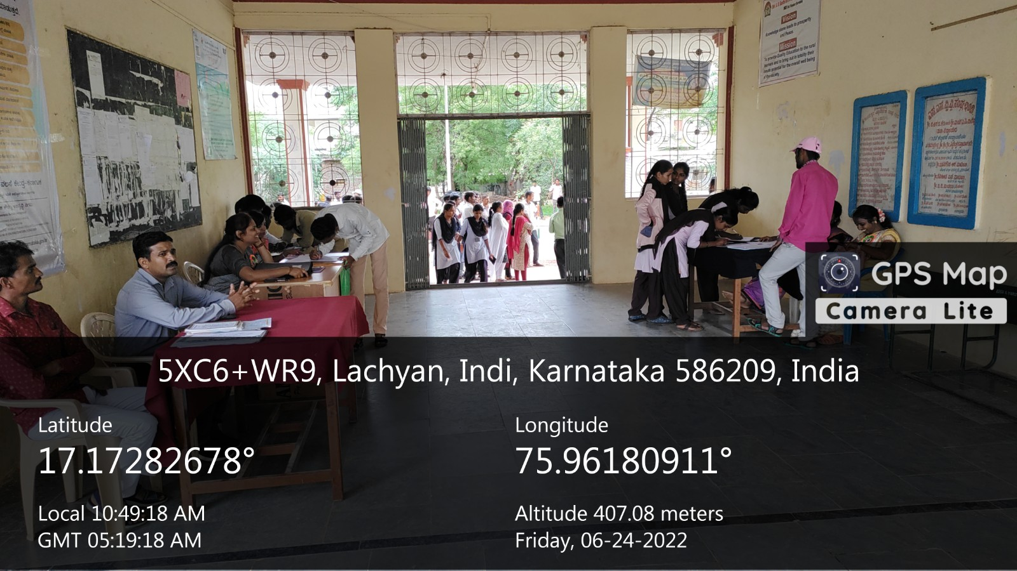
PLACEMENT COMPANY REGISTRATION AND INTERVIEW
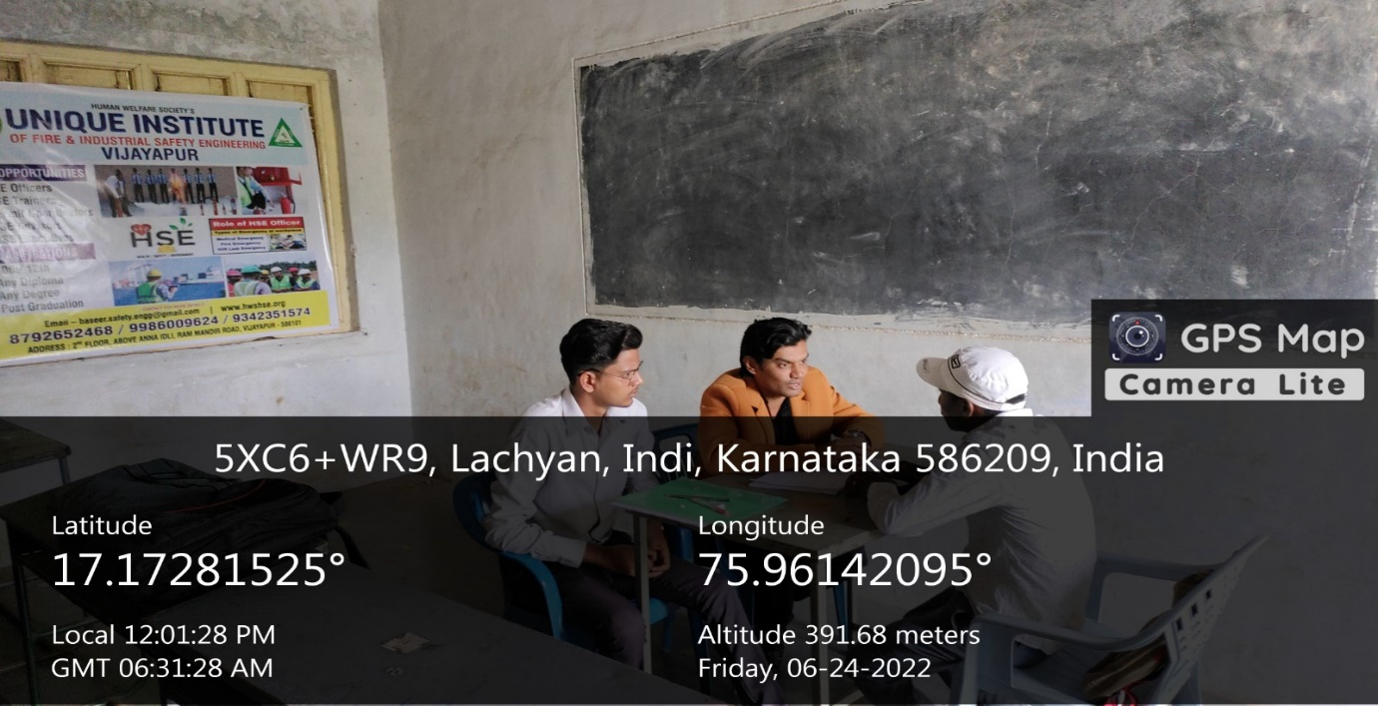
SELECTION LIST OF CANDIDATES
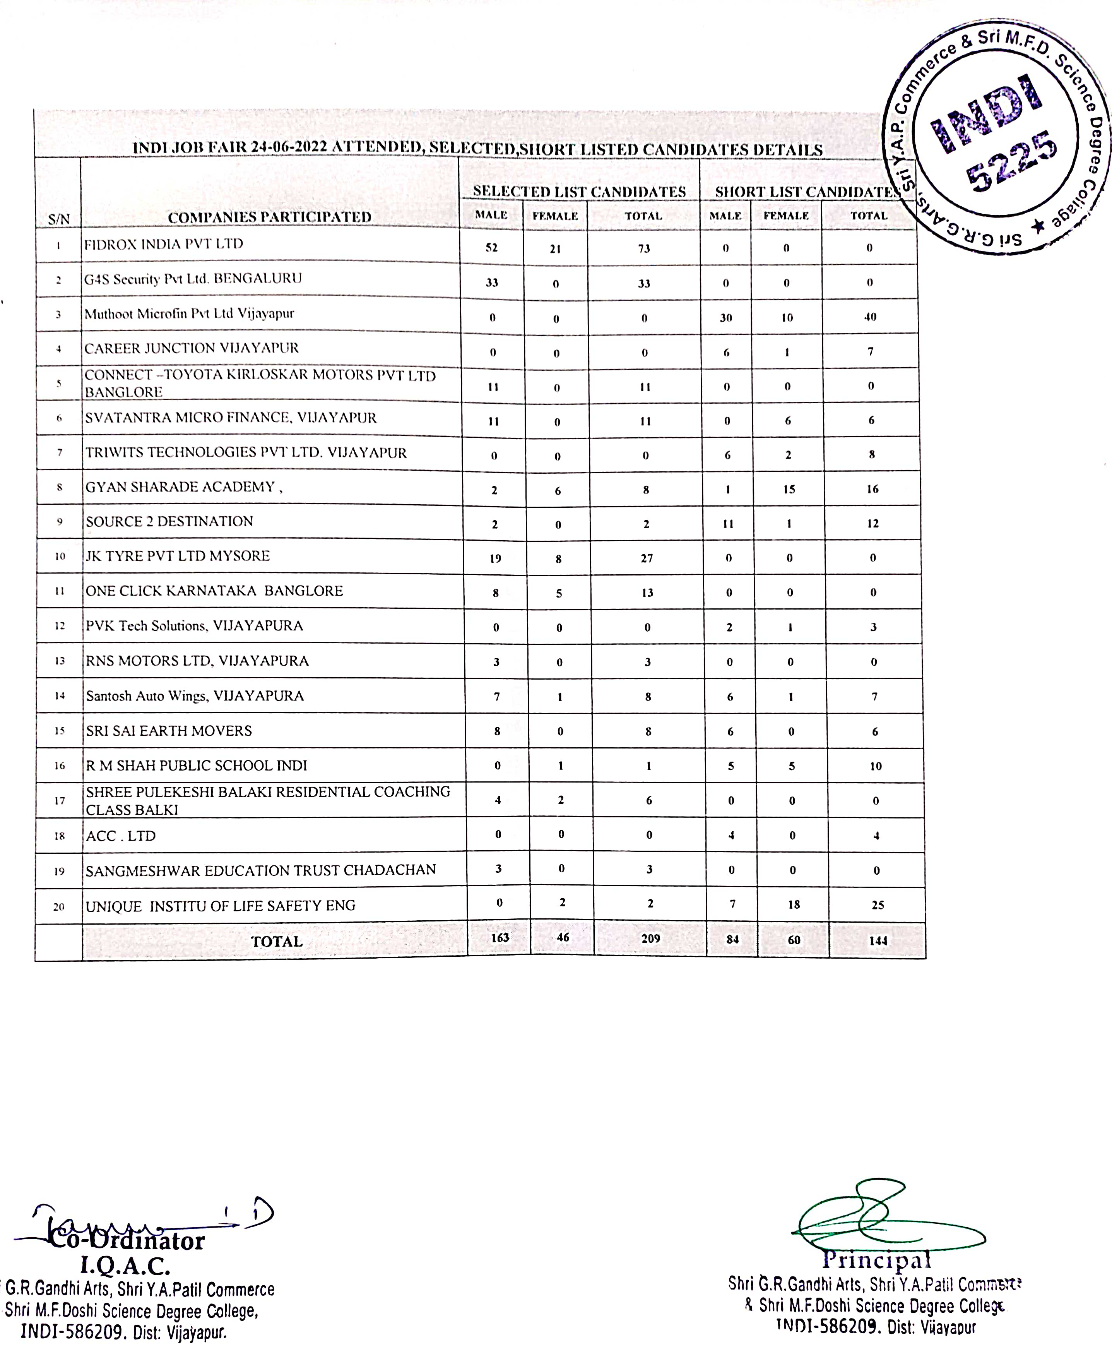
WORKSHOP FOR IAS AND KAS EXAMS
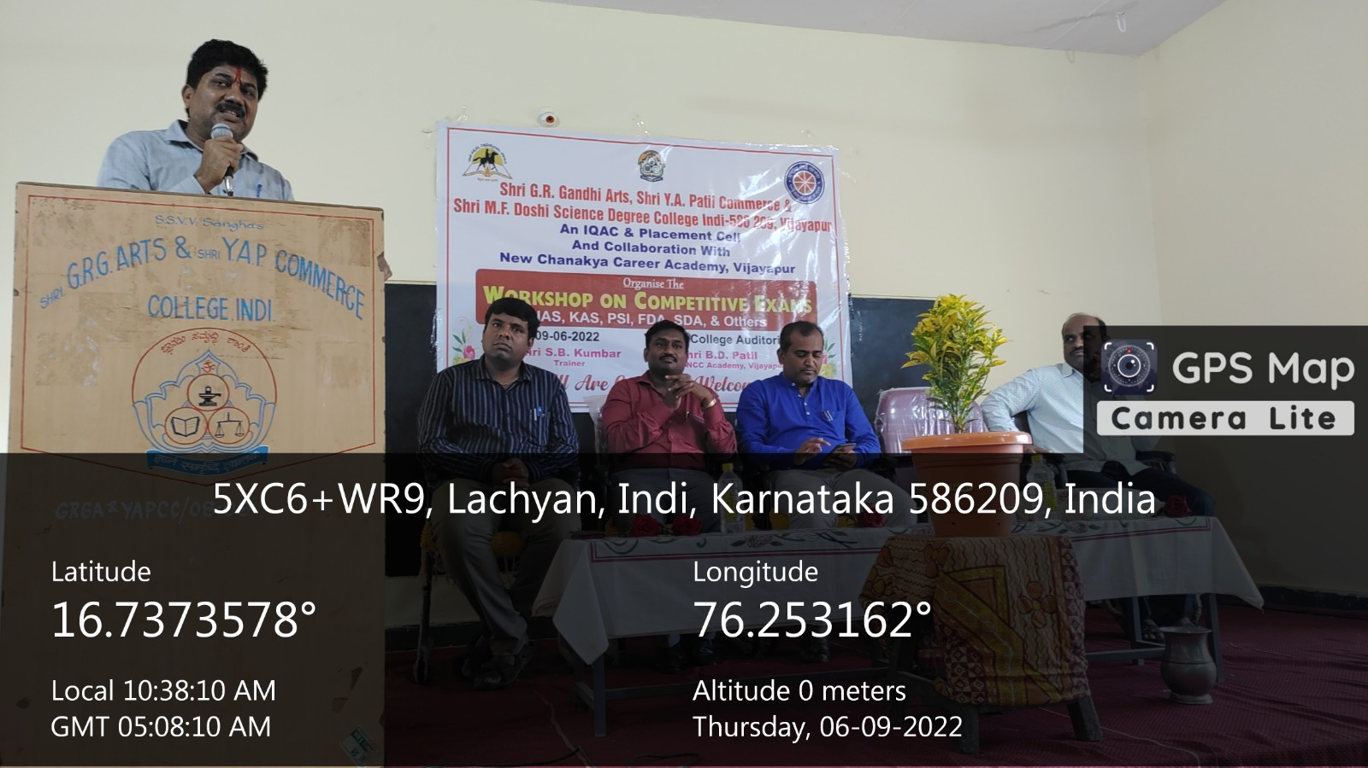
FIELD VISIT AT HALASANGI
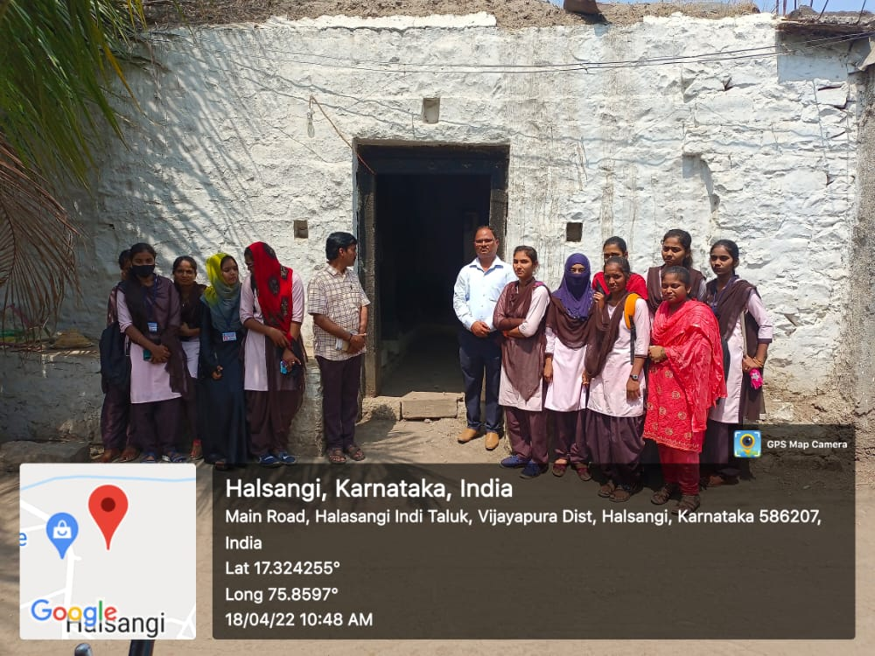

FIELD VISIT AT HALASANGI

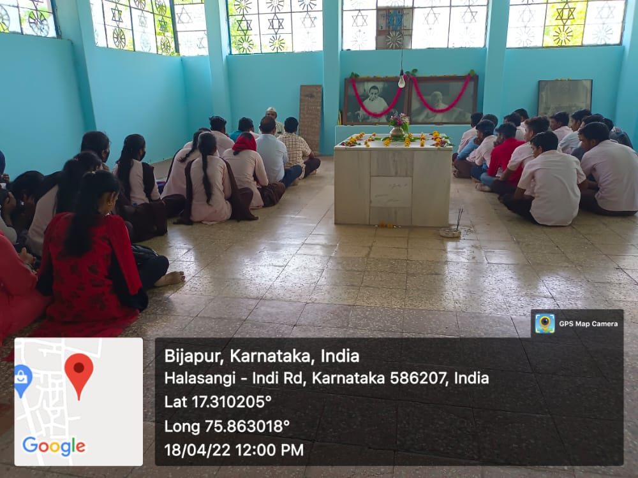
FIELD VISIT AT NAAD SUGAR FACTORY
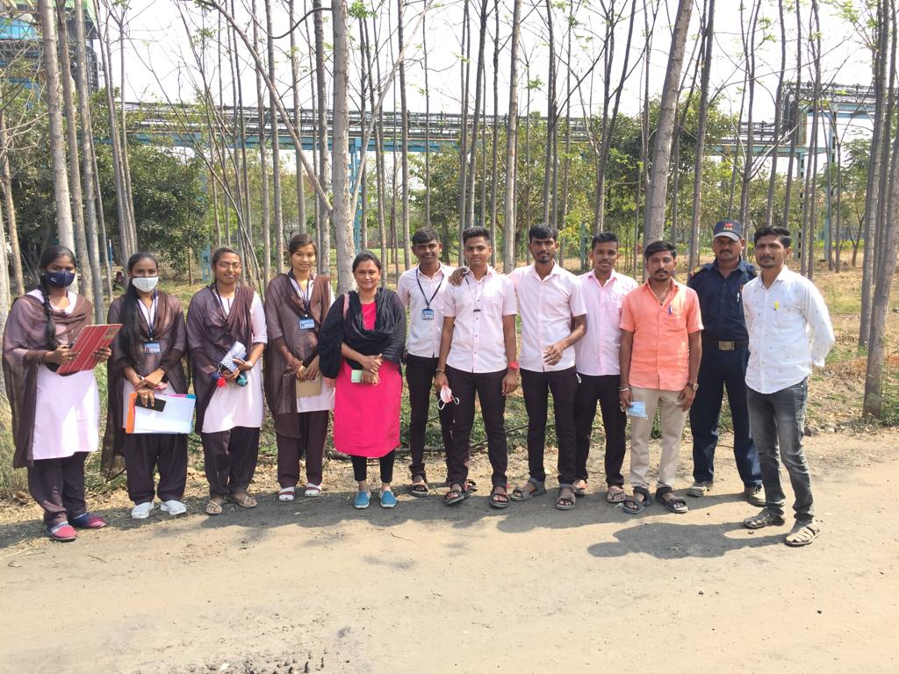

SPECIAL LECTURE ON COMMUNICATION SKILL
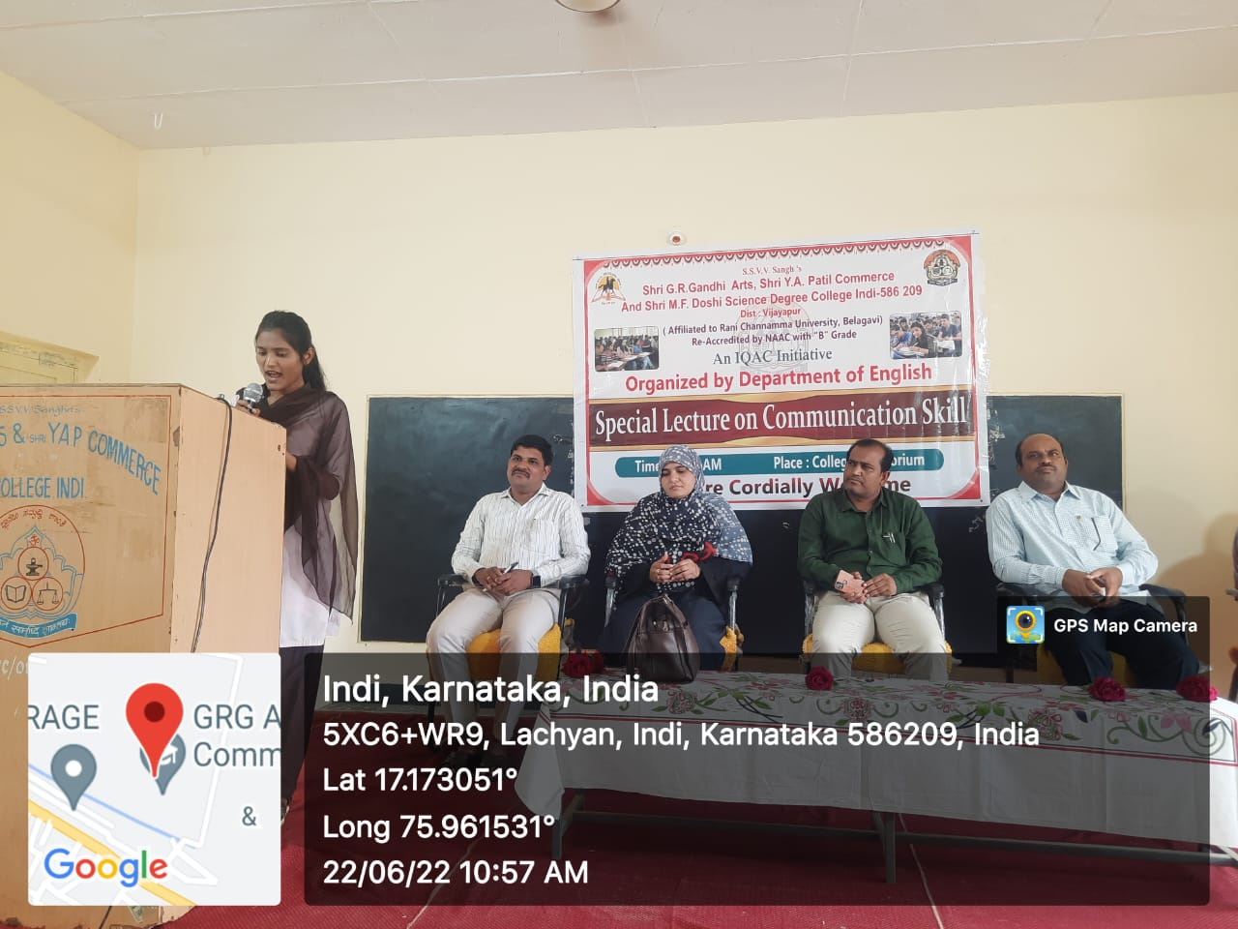
ESSAY COMPETITION
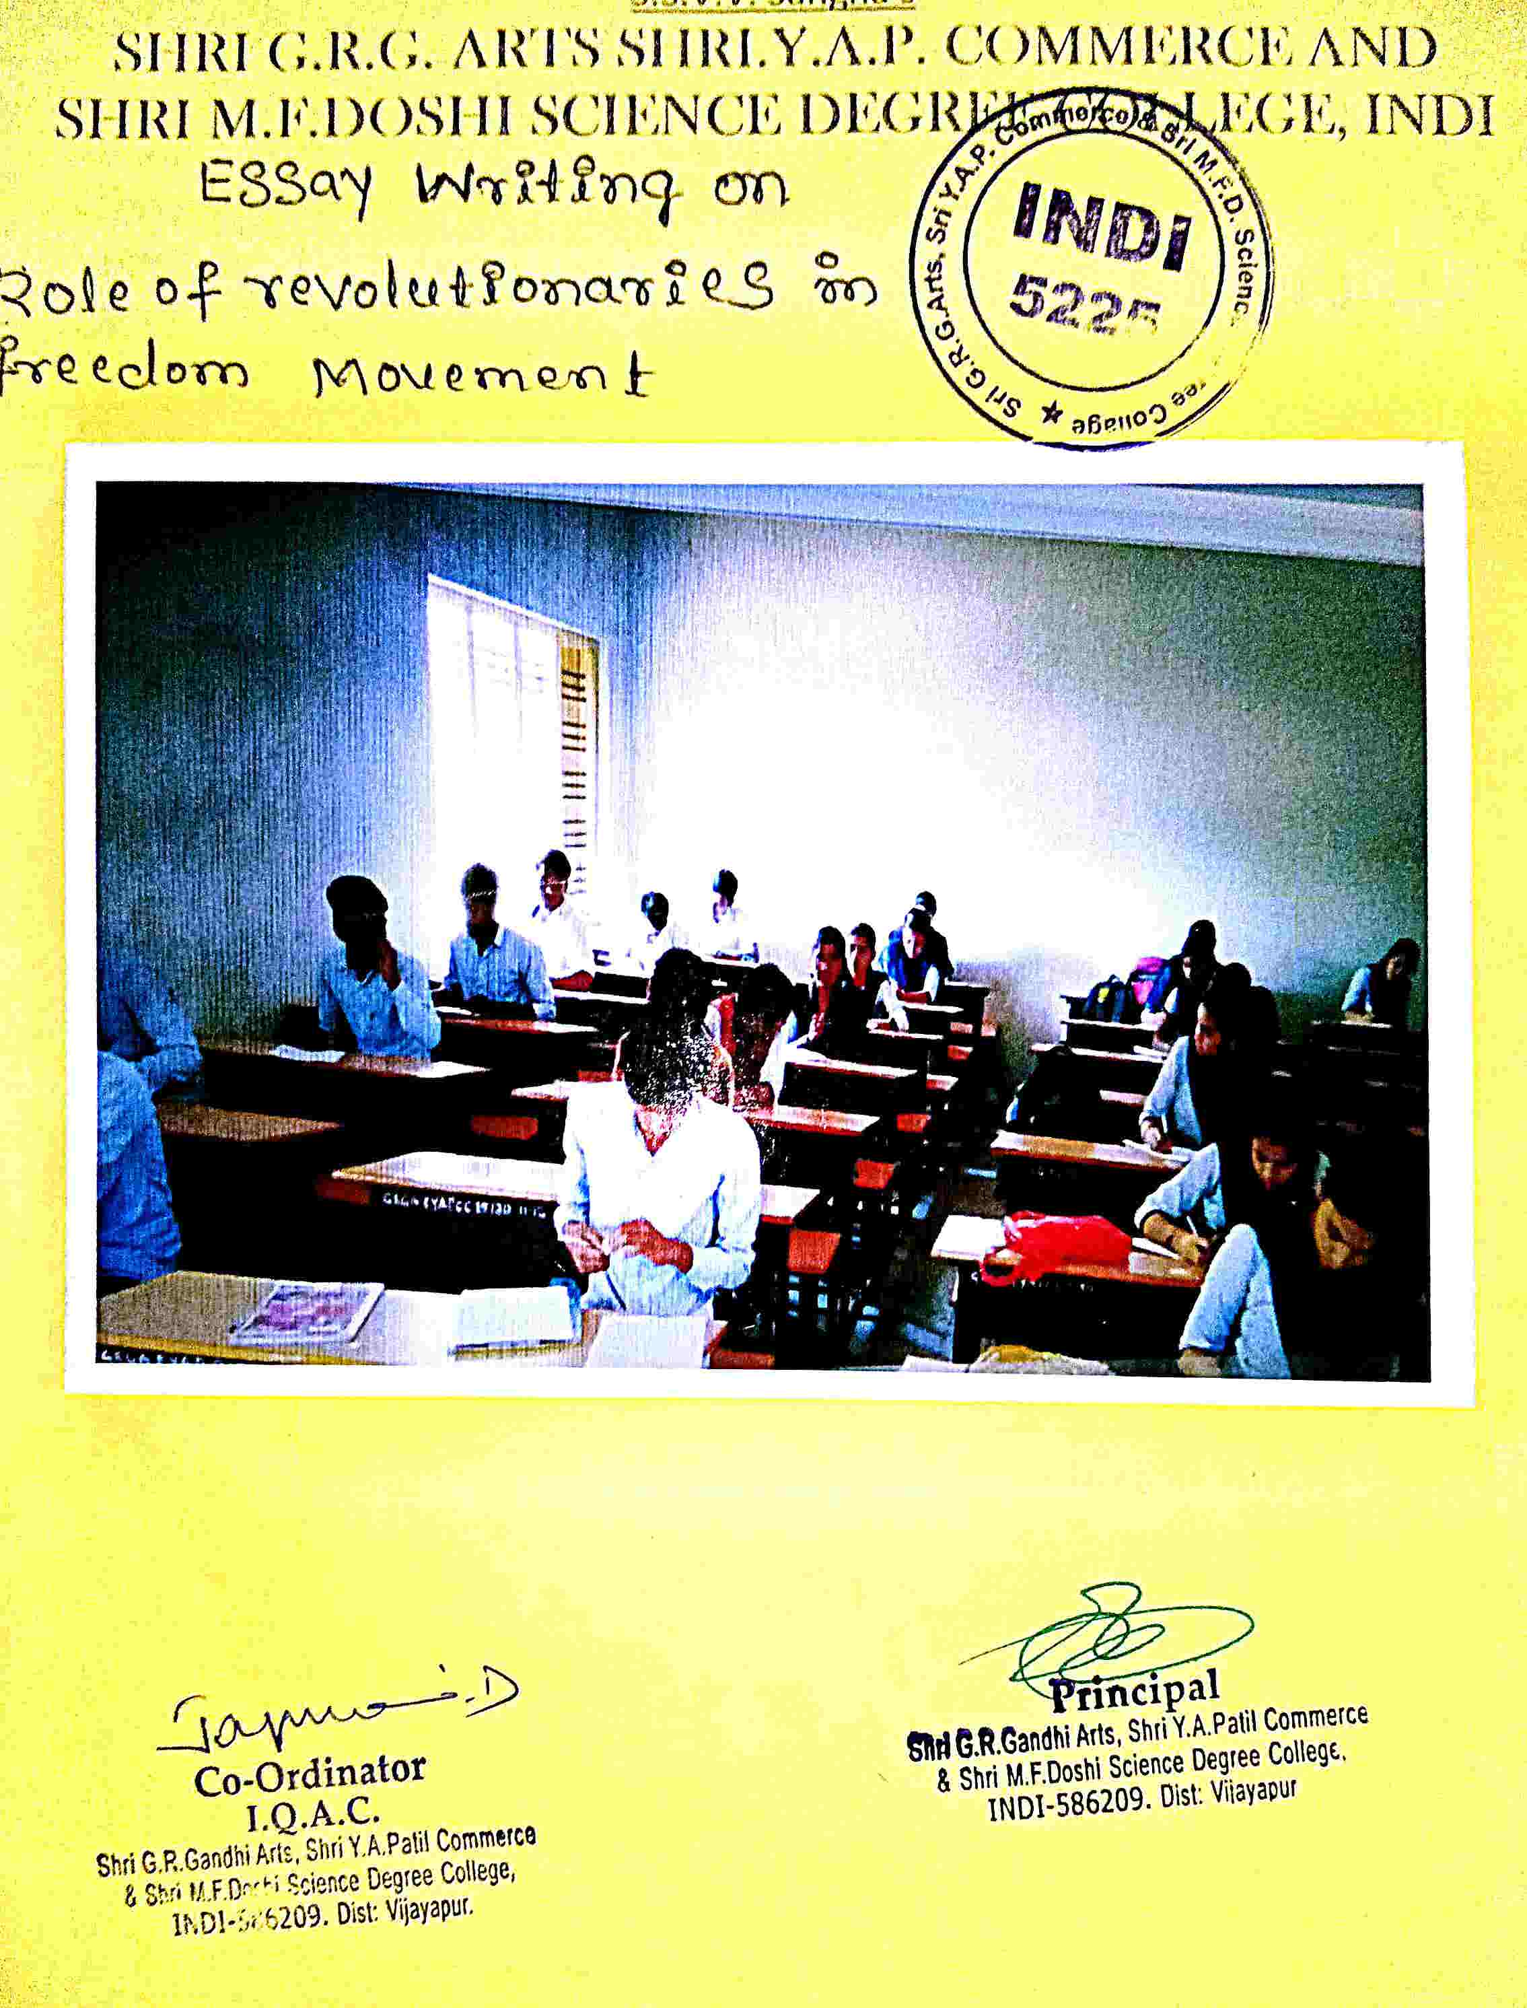
SPEECH COMPETITION
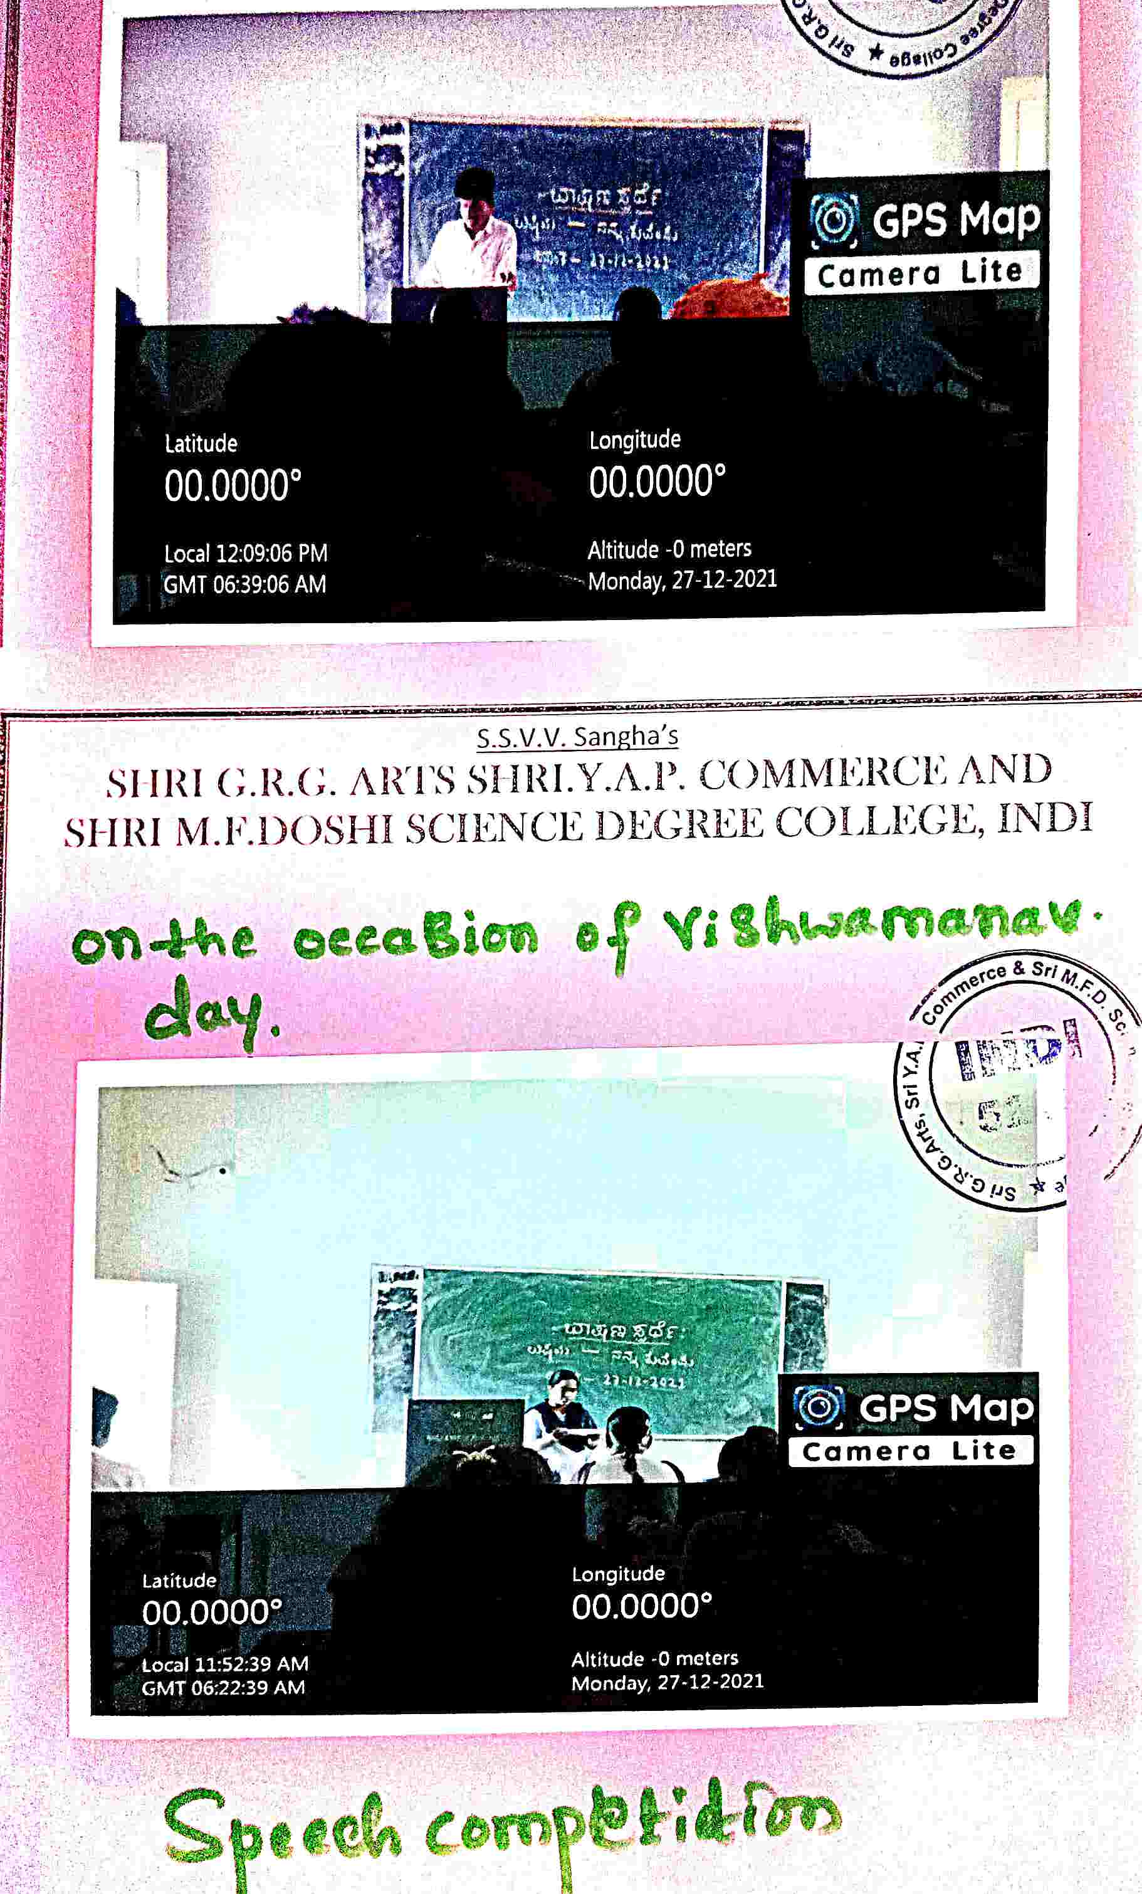
QUIZ COMPETITION
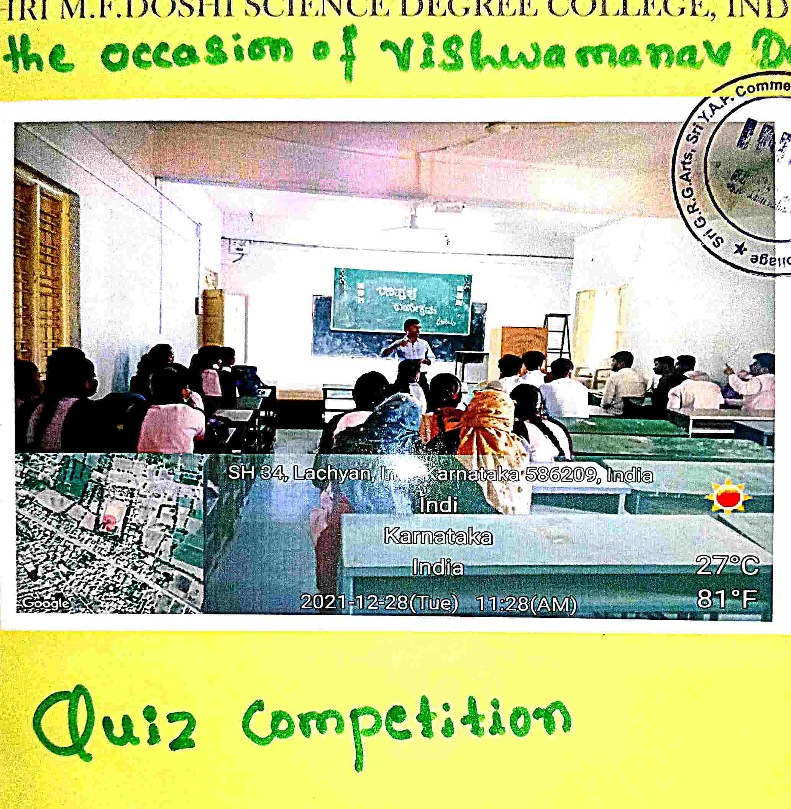
PRIORITY TO SPORTS
OUR COLLEGE KABADDI TEAM AT CHADACHAN COLLEGE
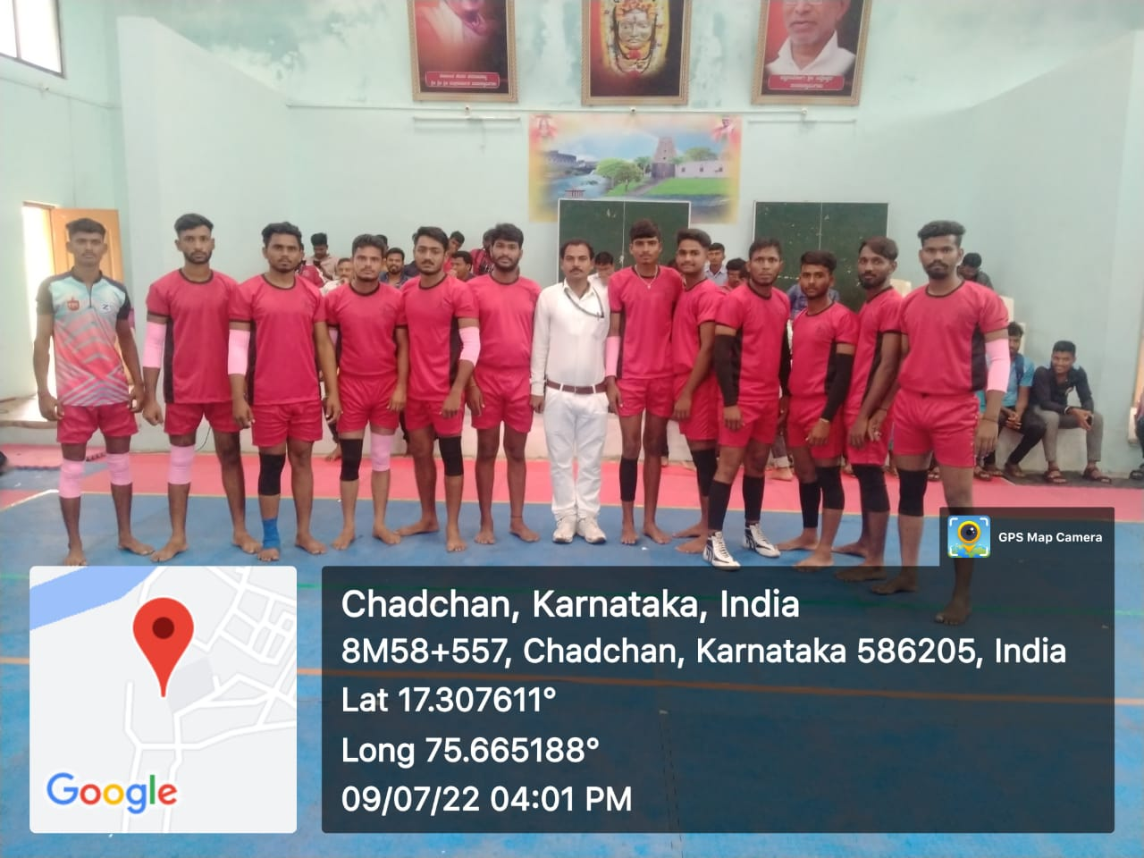

OUR COLLEGE KABADDI TEAM AT CHADACHAN COLLEGE
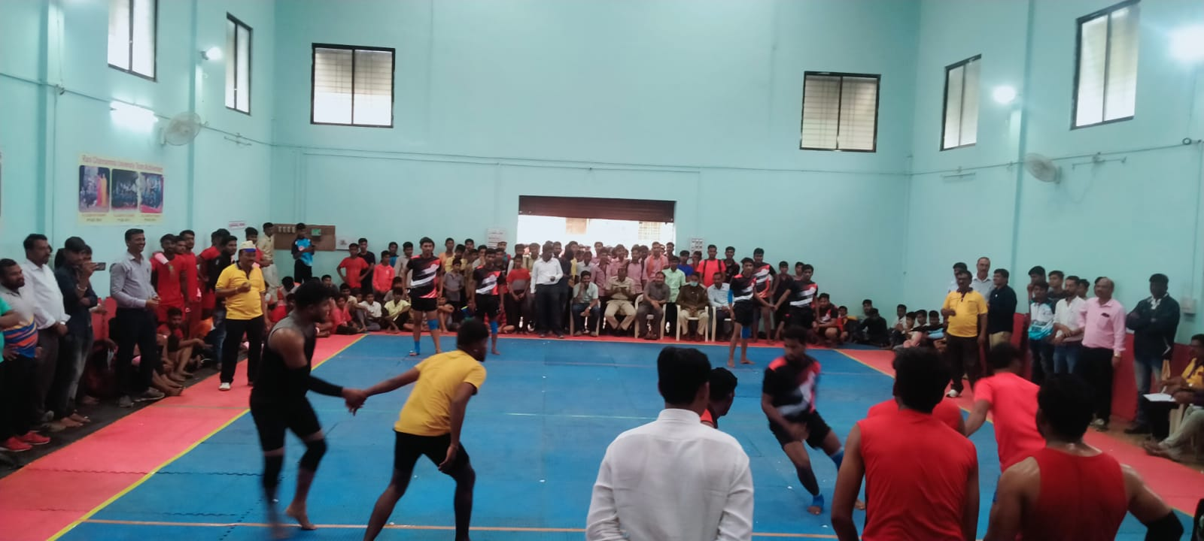
WINNING MOMENT AT VIJAYAPUR ZONAL LEVEL GOT 3RD PRIZE IN KABADDI
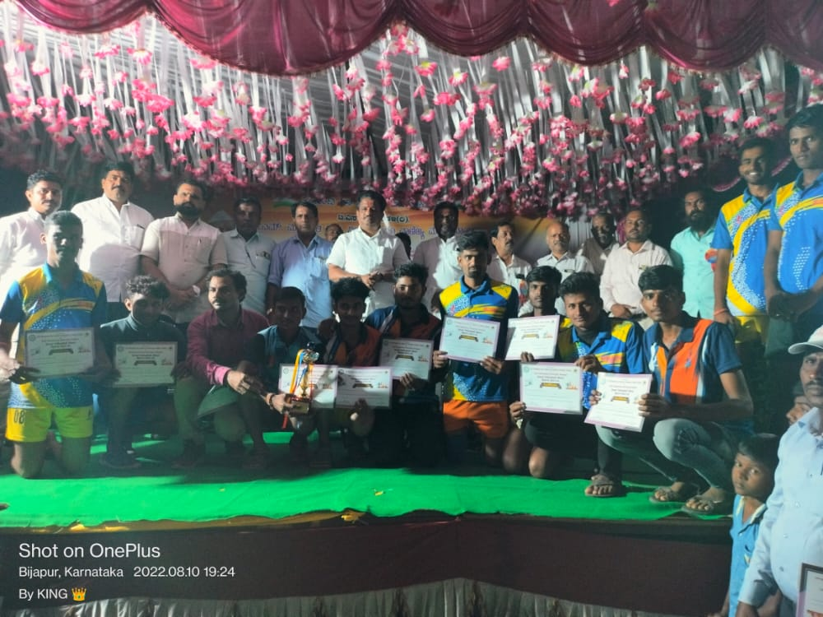

PRIORITY TO SPORTS

